Manuscript English version

|  |
| --- |
| Final manuscript submission after removing this dotted line box   * Do not exceed 10 pages and 5000 words for the entire manuscript includes introduction, method, result, discussion, and conclusion. (Exclude title page, abstract, keywords, and references). * Please provide an abstract of less than 300 words. * The title page should include the name(s) of the author(s), affiliation(s) and address(es) of the authors, and the email address telephone and fax numbers of the corresponding author. * The manuscript should not include any information of author(s). * The manuscript submission should include two files such as manuscript and title page. |

**Association of spinal deformity and pelvic tilt with gait asymmetry in adolescent idiopathic scoliosis patients: investigation of ground reaction force**

**Abstract**

**Objective:** Adolescent idiopathic scoliosis (AIS) is a prevalent orthopedic problem in children ages 10 to 16 years. Although genetic, physiological, and biomechanical factors are considered to contribute to the onset and progression of AIS the underlying mechanisms of AIS are not yet clear

**Methods:** Fourteen adolescents with idiopathic scoliosis (3 males and 11 females) participated in this study. Maximum Cobb’s angle (MCA), adjusted Cobb’s angle (ACA), and pelvic tilt (PT) were calculated from X-ray images.

**Results:** AI of GRF magnitudes positively correlated with ACA and MCA mainly during the peak of braking phase (r= 0.644 for ACA), average of braking phase (r= 0.675 for ACA, r= 0.571 for ACA, p<.01), while AI of GRF time variables showed no significant correlation with MCA or ACA. In contrast, AI of GRF time variables positively correlated with PT (r= 0.611 for braking time, r=0.711 for propulsion time and r= 0.829 for stance time , p<.01) during stance phase.

**Conclusion:** We concluded that the spinal deformity of AIS patients estimated using the maximum and adjusted Cobb’s angles is generally associated with greater asymmetry of GRF magnitudes in walking, while the pelvic tilt is associated with the greater asymmetry of GRF time variables.

*Keywords* **:** Scoliosis, Gait asymmetry, Cobb’s angle, Pelvic tilt, GRF

**Introduction**

Adolescent idiopathic scoliosis (AIS) is a prevalent orthopedic problem in children ages 10 to 16 years (Roubal, Freeman, & Placzek, 1999; Weinstein, Dolan, Cheng, Danielsson, & Morcuende, 2008). AIS is reported to have an onset rate as high as 3% in this age range (Enoka et al., 2003). We predicted that the spinal deformity in the frontal plane caused by AIS might cause asymmetrical mass distribution of the upper body in the medial-lateral direction, which may cause between-limb differences in GRF magnitudes.

**Methods**

1.Participants

Fourteen AIS patients participated in the study: 3 males and 11 females with the average age of 15.2 years (SD 1.3). Two different Cobb’s angles and a pelvic tilt angle were calculated from each subject’s X-rays (Table 1; refer to the data analysis section for measurement details). All the participants gave informed consent based on the procedures approved by Institutional Review Board Human Research.

2. Procedure

The human experimentation has been approved by the University Institutional Review Board. Each subject received information regarding the purpose and methods of the study and signed a university approved consent form. The average walking speed of the subjects was 1.22 m/s (SD 0.17), which was similar to previously reported walking speeds for this age group (Mahaudens, Thonnard, & Detrembleur, 2005).

3. Data analysis

3.1 Quantification of spinal deformity and pelvic tilt

Cobb’s angle is often measured as the angle between lines drawn parallel to the two most tilted vertebrae of the spinal curvature in the frontal plane (James, 1976), but there are often cases in which two or more curvatures are present in the spine.

3.2 Calculation of GRF asymmetry

To assess the gait asymmetry between legs in GRF variables, the Asymmetry Index (AI) was calculated using the following formula (Eq. 1) (Robinson, Herzog, & Nigg, 1987).

$AI =\frac{R-L}{0.5 * \left(R+L\right)}$ (Eq. 1)

where R and L represent the values of a specific GRF component from the right foot and left foot, respectively.

**Results**

1. GRF peaks and averages

AI’s of four GRF magnitude variables (Figure 3) showed statistically significant correlation coefficients with ACA or MCA, while none of the GRF magnitude variables showed significant correlation coefficients with PT (Table 2).

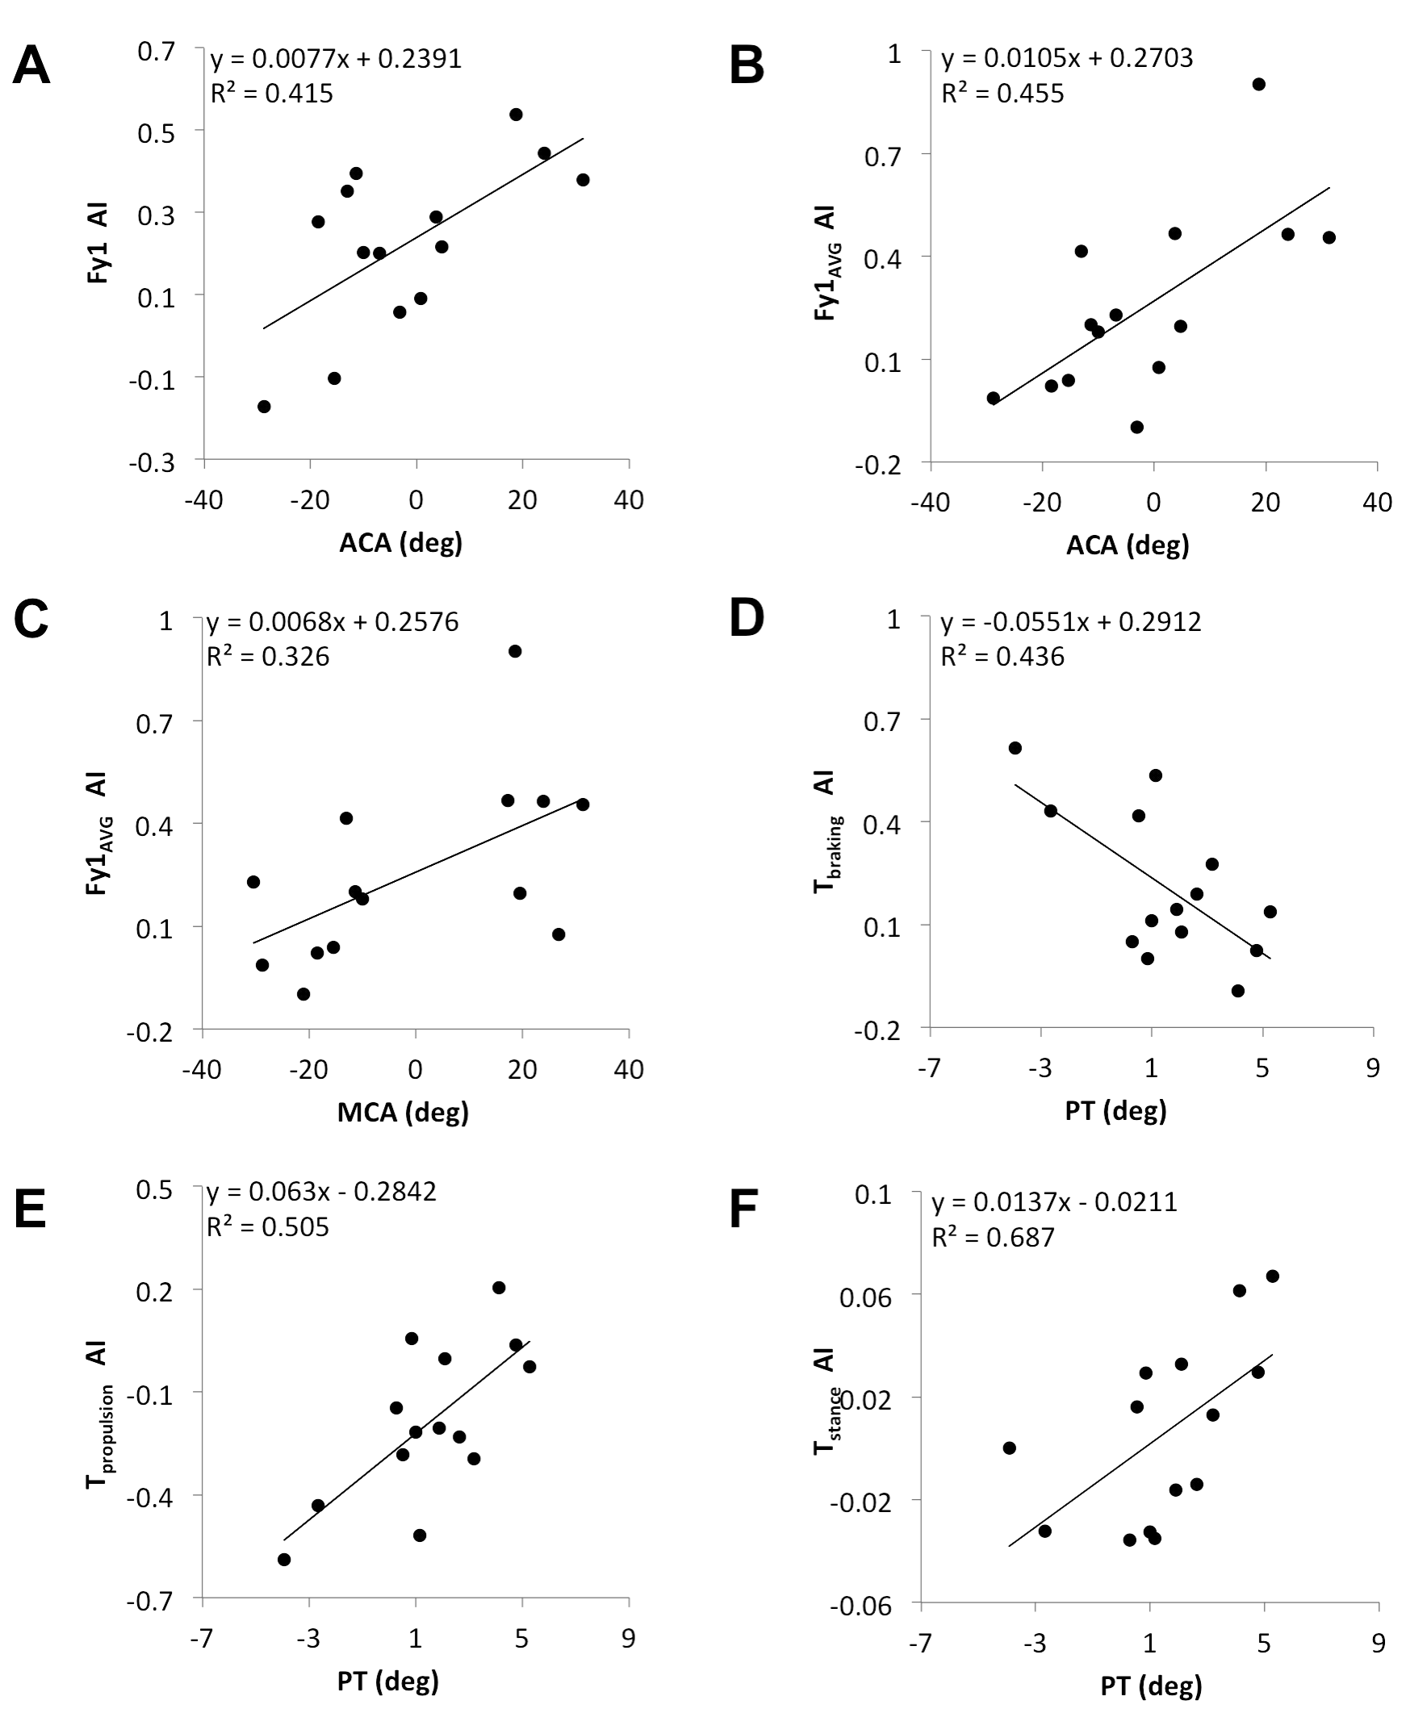

Figure 3. Statistically significant relationships between AI’s of GRF variables vs. ACA (A,B). A, and B regression analysis between the ACA (abscissa) and AI of Fy1, and AI of Fy1 AVG (ordinate). Correlation of determinations (*R2*) and linear regression models are shown from simple regression analysis.

2. GRF temporal parameters

AI’s of braking phase (Tbraking ) and propulsion phase (Tpropulsion) of stance phase contact time and total stance time (Tstance) showed significant correlation coefficients with PT , while AI’s of GRF time variables showed no significant correlation coefficients with MCA or ACA (Table 2).

Table 2. Correlation coefficients of adjusted Cobb’s angle (ACA), maximum Cobb’s angle (MCA), and pelvic tilt (PT) vs. asymmetry index (AI) of gait variables

|  |  |  |  |  |  |  |  |  |  |
| --- | --- | --- | --- | --- | --- | --- | --- | --- | --- |
| ACA | | | | MCA | | | PT | | |
|  | r | *p* | B-H | r | *p* | B-H | r | *p* | B-H | |
| Force variables | | | | | | | | | |
| Fy1AVG | 0.675 | 0.008 | 0.008 | 0.571 | 0.033 | 0.015 | 0.008 | 0.978 | 0.100 | |
| Fy2AVG | 0.133 | 0.650 | 0.069 | 0.225 | 0.439 | 0.108 | 0.433 | 0.122 | 0.054 | |
| |FyAVG| | 0.464 | 0.095 | 0.023 | 0.357 | 0.210 | 0.046 | 0.298 | 0.301 | 0.085 | |
| ACA: adjusted Cobb’s angle, MCA: maximum Cobb’s angle, PT: angle of pelvic tilt. Correlation coefficients that are statistically significant considering Benjamini-Hochberg (B-H) critical vaules are shown in bold. | | | | | | | | | |

**Discussion**

Previous studies have reported that between-leg asymmetry in GRF during locomotion has been found in patients with neuromusculoskeletal problems in one of the legs (Beattie, Isaacson, Riddle, & Rothstein, 1990; Gurney, 2002; Kaufman, Miller, & Sutherland, 1996; Patterson et al., 2008).

**Conclusions**

In summary, our study shows that the gait asymmetry of A-P magnitudes and time variables of GRF are associated with the severity of the spinal deformities and pelvic tilt caused by AIS. We concluded that the spinal deformity is generally associated with the between-leg asymmetry in A-P GRF magnitudes, while the pelvic tilt is associated with the asymmetry of the time variables.

**Reference**

Winter, D. A. (1990). *Biomechanics and Motor control of Human Movement. 2nd edition.* Wiley-Interscienc Publication, New york : John Wiley & Sons, Inc.

Karol, S., Kim, Y.-S., Huang, J., Kim, Y. H., Koh, K., Yoon, B. C., & Shim, J. K. (2011). Multi-finger pressing synergies change with the level of extra degrees of freedom. *Experimental brain research, 208*(3), 359-367.

Enoka, R. M., Christou, E. A., Hunter, S. K., Kornatz, K. W., Semmler, J. G., Taylor, A. M., & Tracy, B. L. (2003). Mechanisms that contribute to differences in motor performance between young and old adults. *Journal of Electromyography and Kinesiology, 13*(1), 1-12.

Yoo, S. H. (2015). *Classification of the Hand Techniques by Angular Momentum in the Taekwondo Poomsae*. Un- published Doctor's Dissertation (or Master's Thesis). Graduate School of Korea National Sport University.

Sun, L. H. & Dennis, B. (2016, July, 18). Elderly Zika patient in Utah may have infected a family contact. *The Washington Post.* Retrieved from https://www.washingtonpost.com/news/to-your-health/wp/2016/07/18/elderly-zika-patient-in-utah-may-have-infected-a-family-contact.

Abdel-Aziz, Y. I., & Karara, H. M. (1971). Direct linear transformation from comparator coordinates in object-space coordinates in close range photogrammetry. Proceedings of the ASP Symposium of Close-Range Photogrammetry. Urbana: University of Illinois.

Lim, Y., & Chow, J. (1994 June). Lumbar spinal loads: Application to tennis serve. Poster session presented at the annual meeting of the mid-west biomechanics symposium, Chicago.